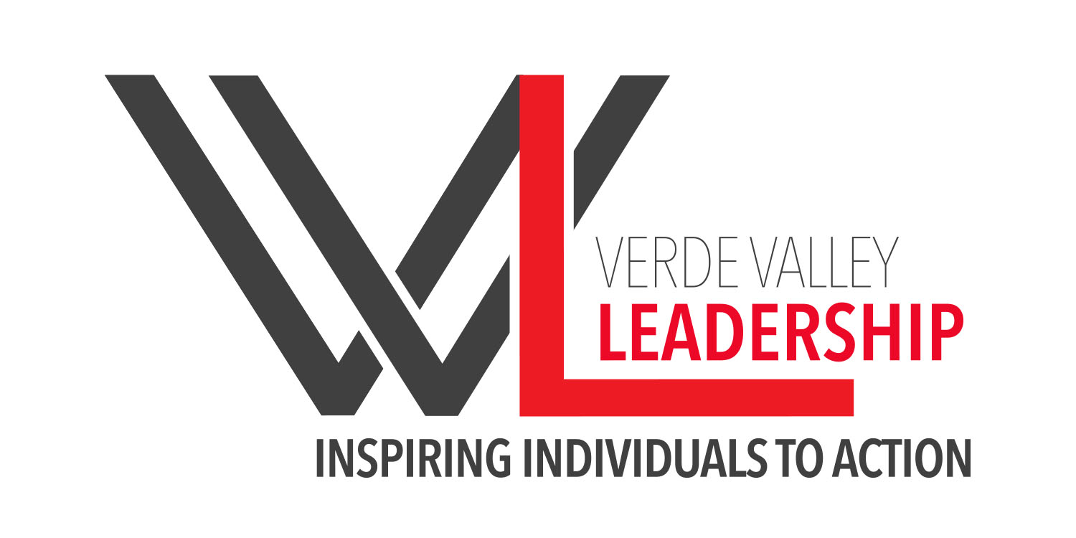
NEWS RELEASE

Verde Valley Leadership, Inc., PO Box 1663, Cottonwood AZ 86326

For Immediate Release

Date:
Contact:
Phone:

*** BODY ***

Verde Valley Leadership is about inspiring individuals to action through skills development and active engagement in the community. For more information about Verde Valley Leadership or applying for next year’s class visit our website at www.vvleadership.org or contact us at info@vvleadership.org.

###

Established in 2006, Verde Valley Leadership is a 501(c)3 non-profit organization.

